**User manual for MNPBEM-GUI V2**

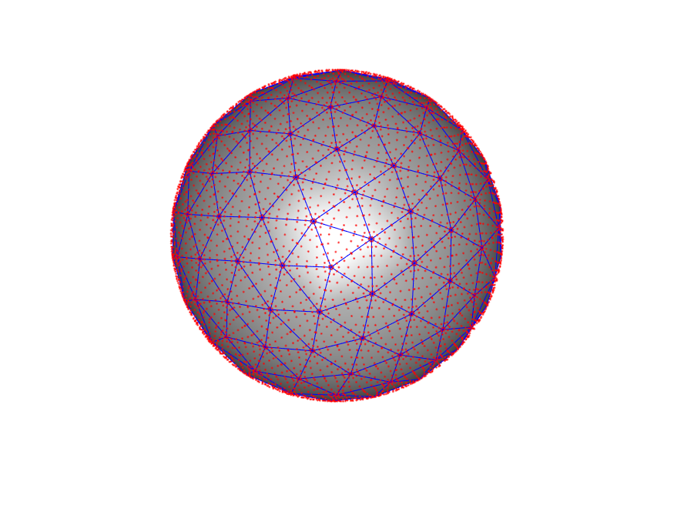

Contents

Introduction to MNPBEM-GUI 3

Information about the MNPBEM toolbox 3

MNPBEM help files and support 3

How to start MNPBEM-GUI 4

Installing and running MNPBEM-GUI as a Matlab app 4

Basic operation of the MNPBEM-GUI 5

Solver options 5

Calculation toggle 5

Structure 6

Excitation source 8

Permittivity options 8

Energy range, Detector options, Source options 9

Save and load simulation settings 11

Run simulation 11

Save simulation results 11

Help button 11

References 12

# Introduction to MNPBEM-GUI

## Information about the MNPBEM toolbox

MNPBEM-GUI is a graphical user interface for the MNPBEM toolbox (<http://physik.uni-graz.at/mnpbem/download.php>) that provides extra functionality. It supports BEM simulations with Plane wave, Dipole, and Electron beam sources for a variety of structures and materials. It can calculate Charge distributions, near fields, radiative modes, farfield spectra and perform a variety of parametric scan simulations. EELS and cathodoluminescence simulations are also supported.

As also described in the MNPBEM help files, MNPBEM is a toolbox for the simulation of metallic nanoparticles (MNP), using a boundary element method (BEM) approach developed by F. J. Garcia de Abajo and A. Howie, Phys. Rev. B 65, 115418 (2002). The main purpose of the toolbox is to solve Maxwell's equations for a dielectric environment where bodies with homogeneous and isotropic dielectric functions are separated by abrupt interfaces.

No knowledge of the MNPBEM toolbox is required in order to perform simulations with the MNPBEM-GUI. On ther other hand, for advanced use, good understanding of the basic operation of the toolbox is required. Users can introduce their own structures as well as functions in the code.

When publishing results obtained with this toolbox, one or more of the following papers should be cited:

* U. Hohenester and A. Trügler, Comp. Phys. Commun. 183, 370 (2012).
* U. Hohenester, Comp. Phys. Commun. 185, 1177 (2014).
* J. Waxenegger, A. Trügler, and U. Hohenester, Comp. Phys. Commun. 193, 138 (2015).

**Developers of toolbox:** Ulrich Hohenester, Andreas Trügler

**Developer of GUI:** Nikolaos Matthaiakakis

The MNPBEM toolbox is distributed under the terms of the GNU General Public License.

The MNPBEM-GUI was originaly developed by Nikolaos Matthaiakakis for use in the Sannomiya group, Tokyo Institute of Technology.

## MNPBEM help files and support

For more information about the MNPBEM toolbox one can refer to the MNPBEM help files by clicking Help/MNPBEM Toolbox from the user interface of the MNPBEM-GUI. Furthermore user manuals and theoretical background for the MNPBEM toolbox can be found at the referenced material in this document.

**Manuals:**  [1–4]

**Theory:**  [5–8]

## How to start MNPBEM-GUI

In order to start MNPBEM-GUI Matlab is required. Once Matlab is running, MNPBEM-GUI can be started simply by opening MNPBEM_GUI/ MNPBEM-GUI.mlapp which should open up the window of Fig. 1. MNPBEM-GUI is now ready to run. (The basic user should not alter the file structure in the CL_GUI folder as a lot of the files are necessary for its operation).

Creating a shortcut for the MNPBEM_GUI.mlapp file is also possible and when clicked it can start up both Matlab and MNPBEM-GUI.

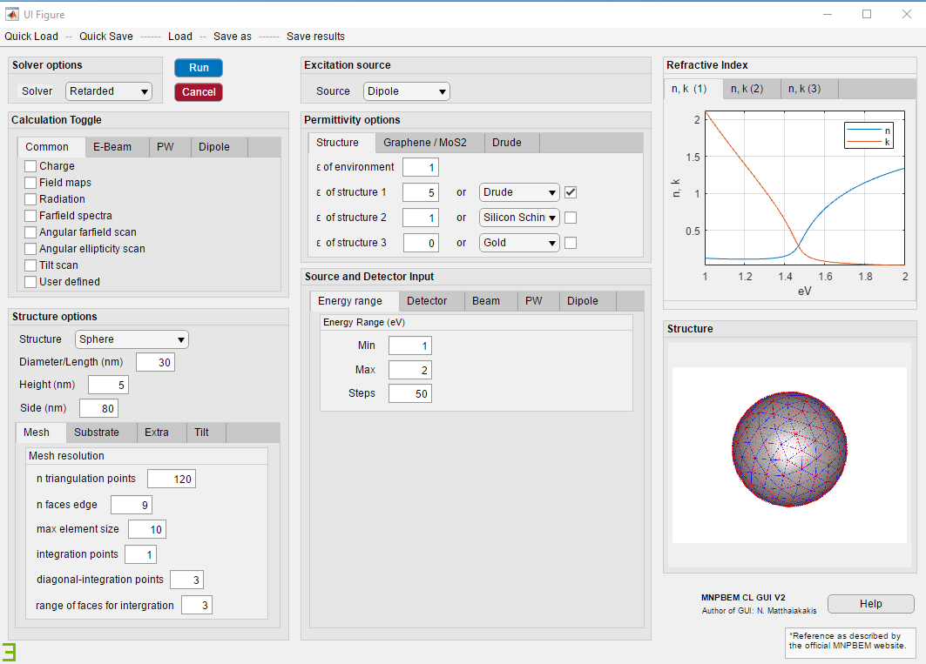

**Figure 1. Interface of the MNPBEM-GUI**

## Installing and running MNPBEM-GUI as a Matlab app

It is very easy to install MNPBEM-GUI as a Matlab app simply by clicking the MNPBEM_GUI/ gui_ MNPBEM.mlappinstall file and clicking install in the popup window of Matlab as seen in Fig. 2. For more information please visit <https://www.mathworks.com/discovery/matlab-apps.html> .

MNPBEM-GUI can then be opened by clicking on the Matlab toolbar/APPS/ _GUI as seen in Fig. 3.

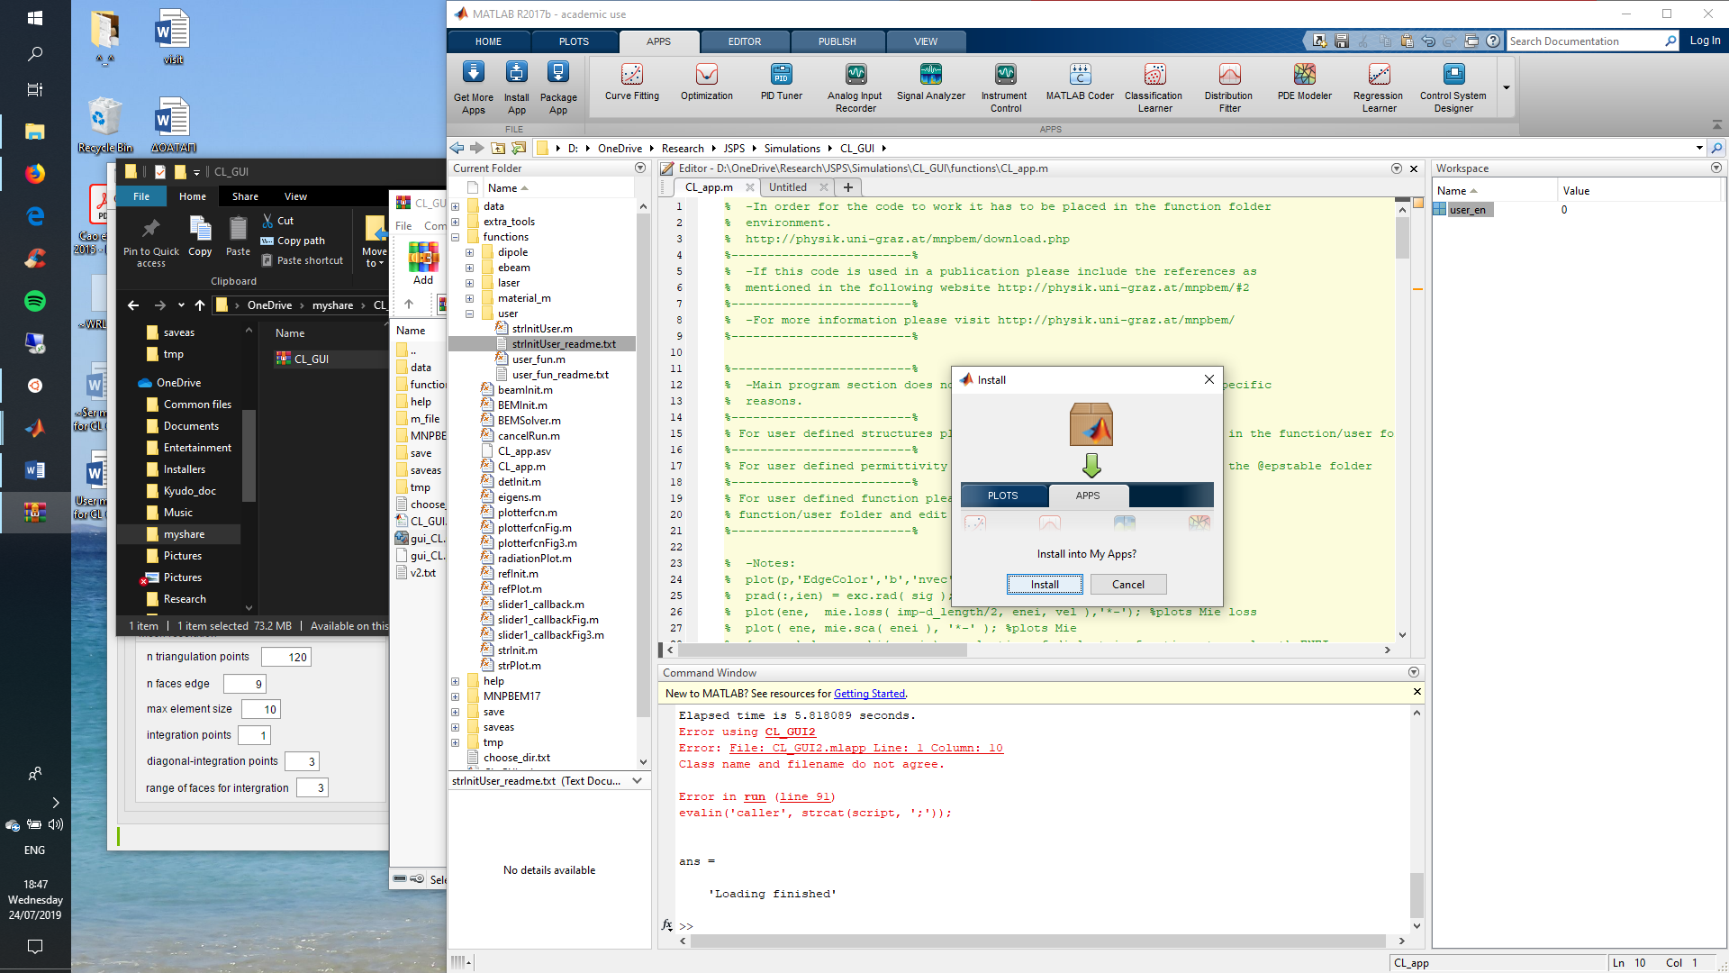

**Figure 2. App installation**

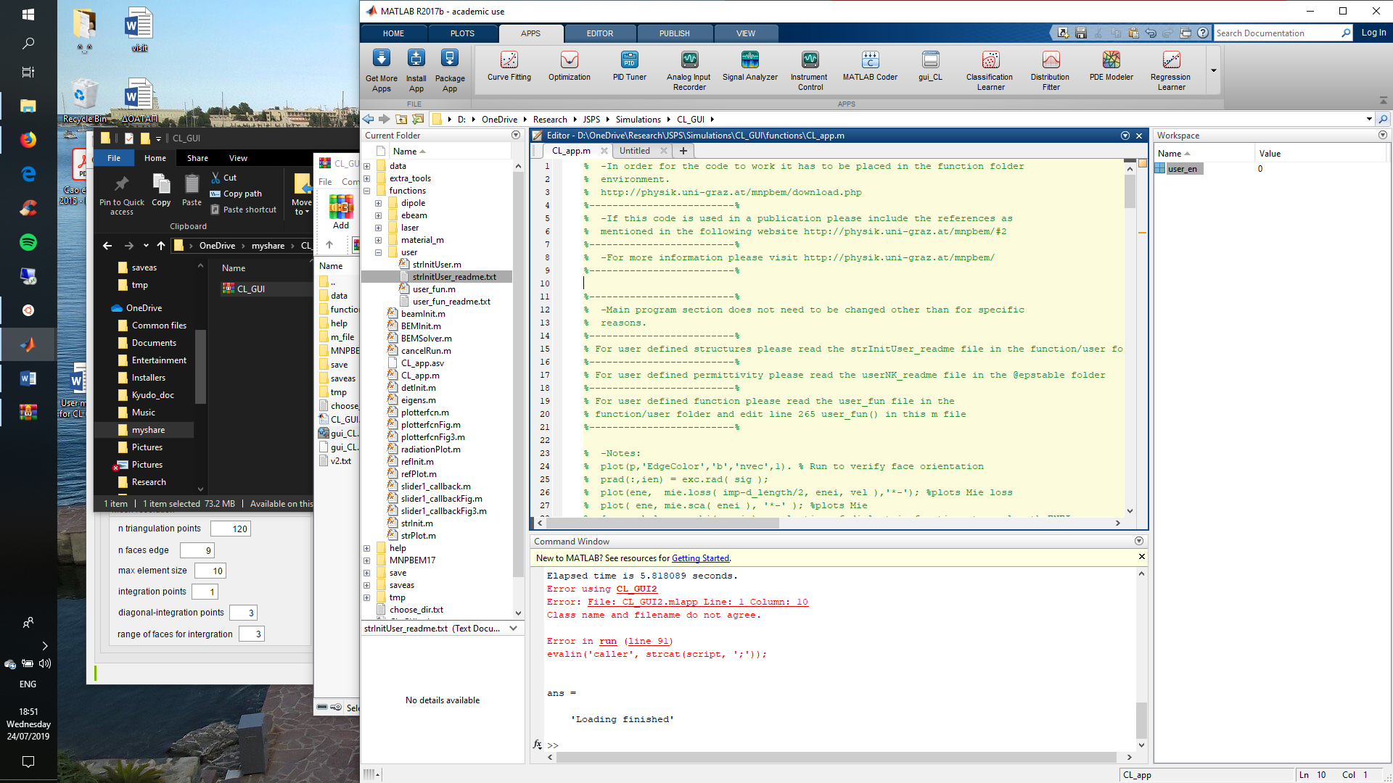

**Figure 3. Start MNPBEM-GUI app**

# Basic operation of the MNPBEM-GUI

## Solver options

Once MNPBEM-GUI is running it is very easy to run simulations. First the user needs to choose the solver type from the **Solver options** dropdown list.

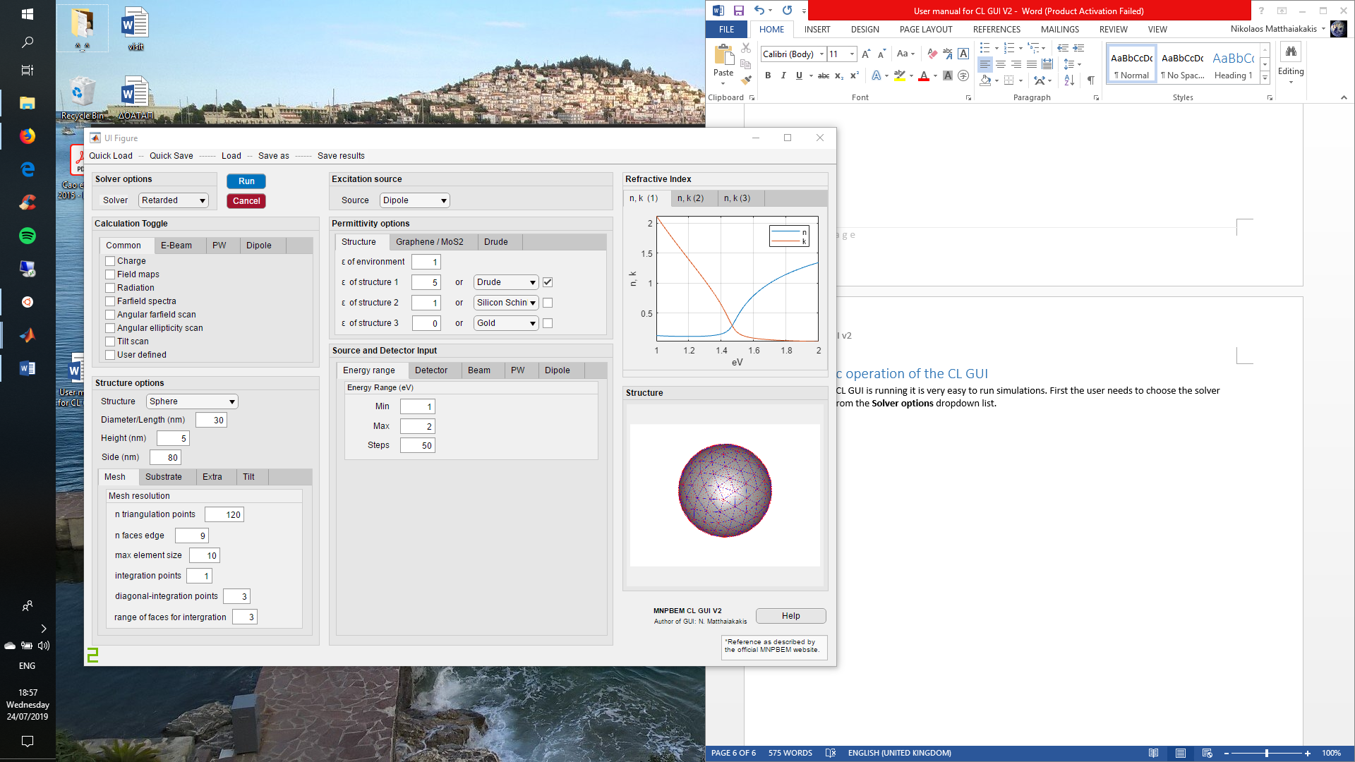

A choice can be made between a Retarded, Quasistatic, and Iterative solver. For high accuracy simulations the retarded solver is recommended but the quasistatic solver can also be used, providing highly accurate results while requiring less computational resources. The Iterative solver is very fast and requires low amount of memory but is currently experimental. For more information the user is referred to the MNPBEM help files and documentation.

## Calculation toggle

From this section the calculation options can be selected. MNPBEM-GUI support many built in calculations including various types of parametric scans to select from.

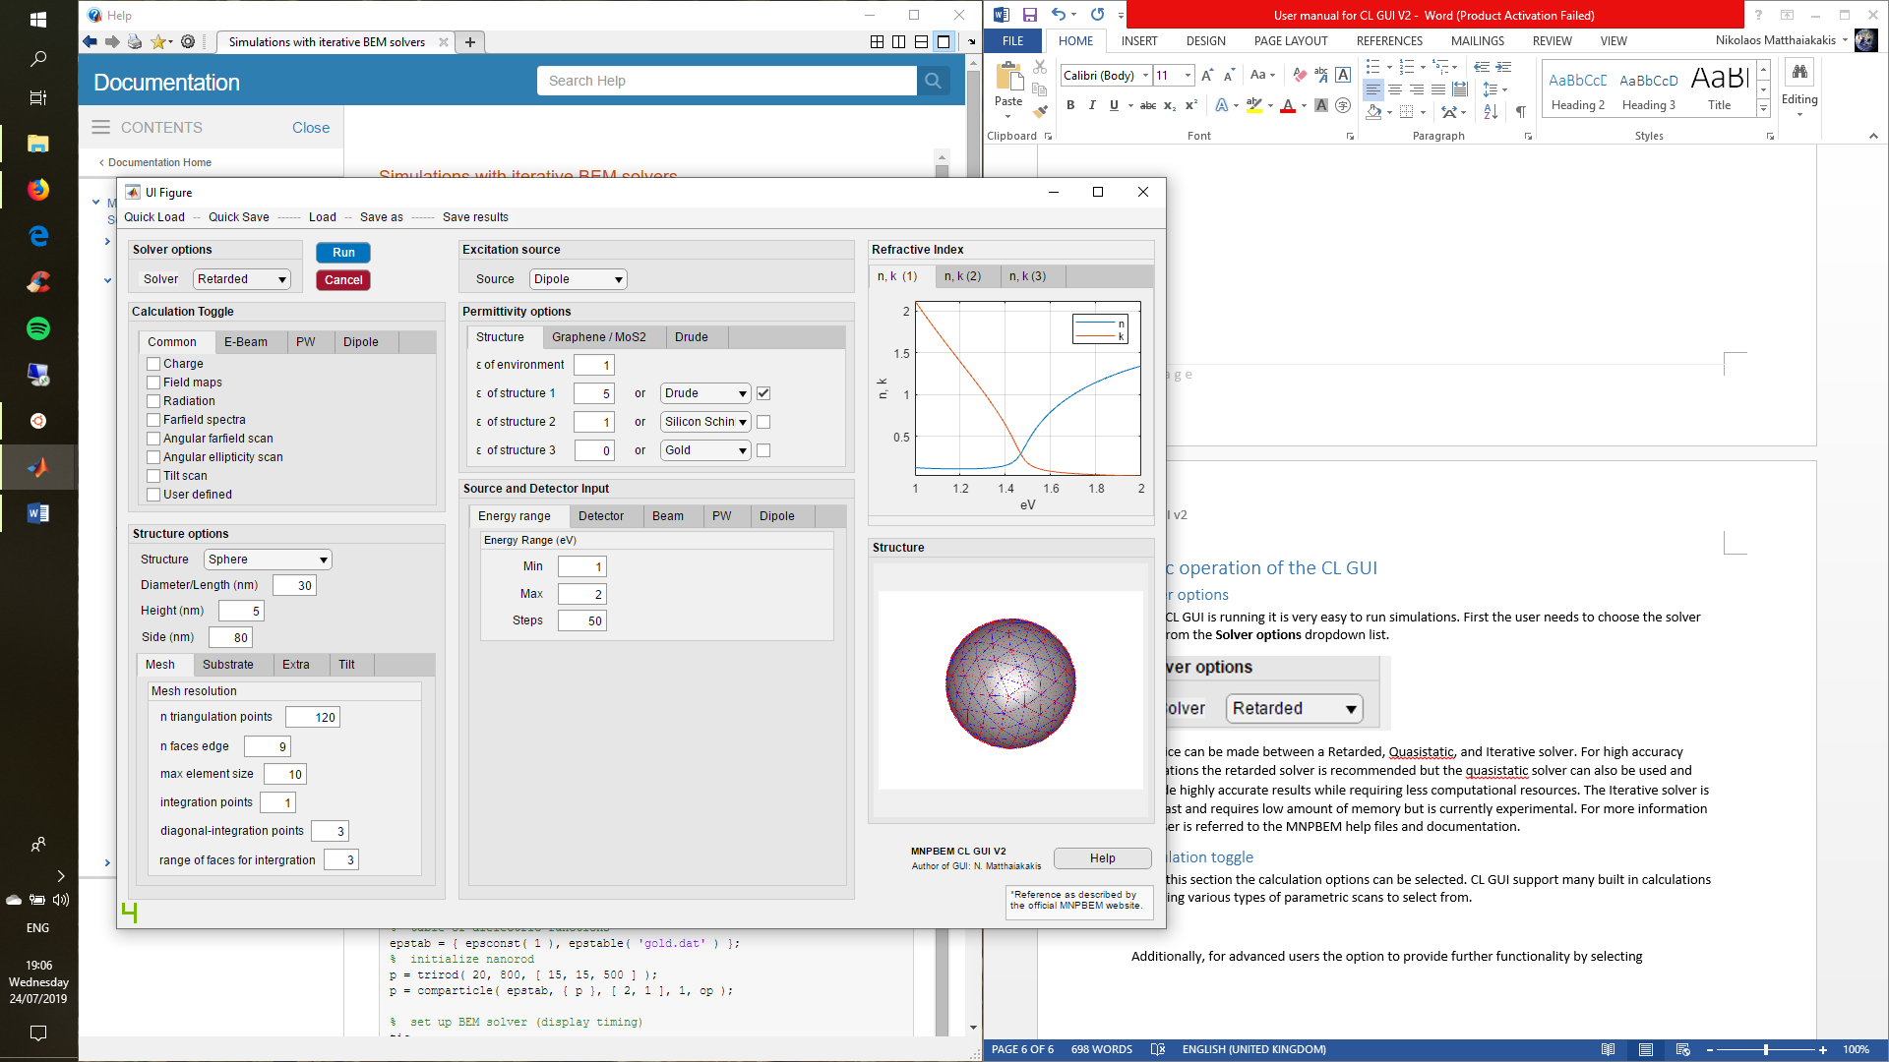

**User defined functions:** For advanced users the option to provide further functionality is possible by selecting the “user defined” checkbox. When checking this checkbox, the user needs to have prepared a function with the appropriate inputs in the MNPBEM_GUI/functions/user/user_fun.m file.

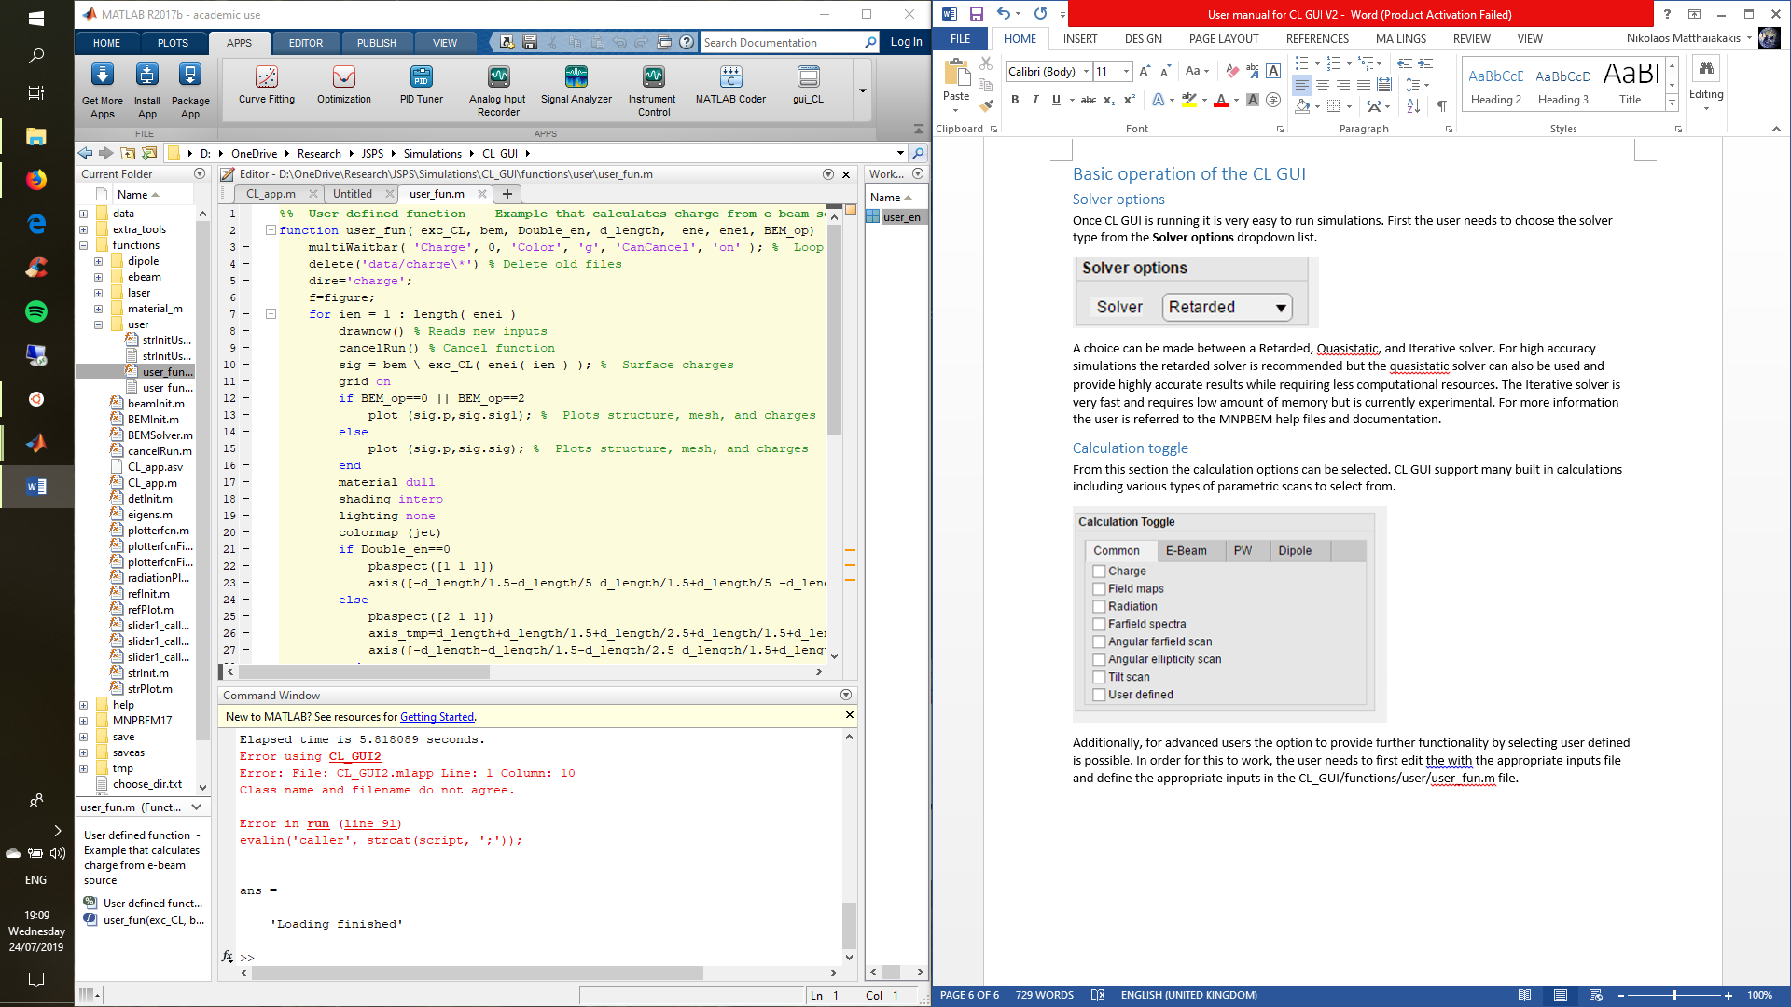

Then, the user must edit the function call user_fun(input1,input2,…) in line 267 of MNPBEM_GUI/functions/CL_app.m accordingly.

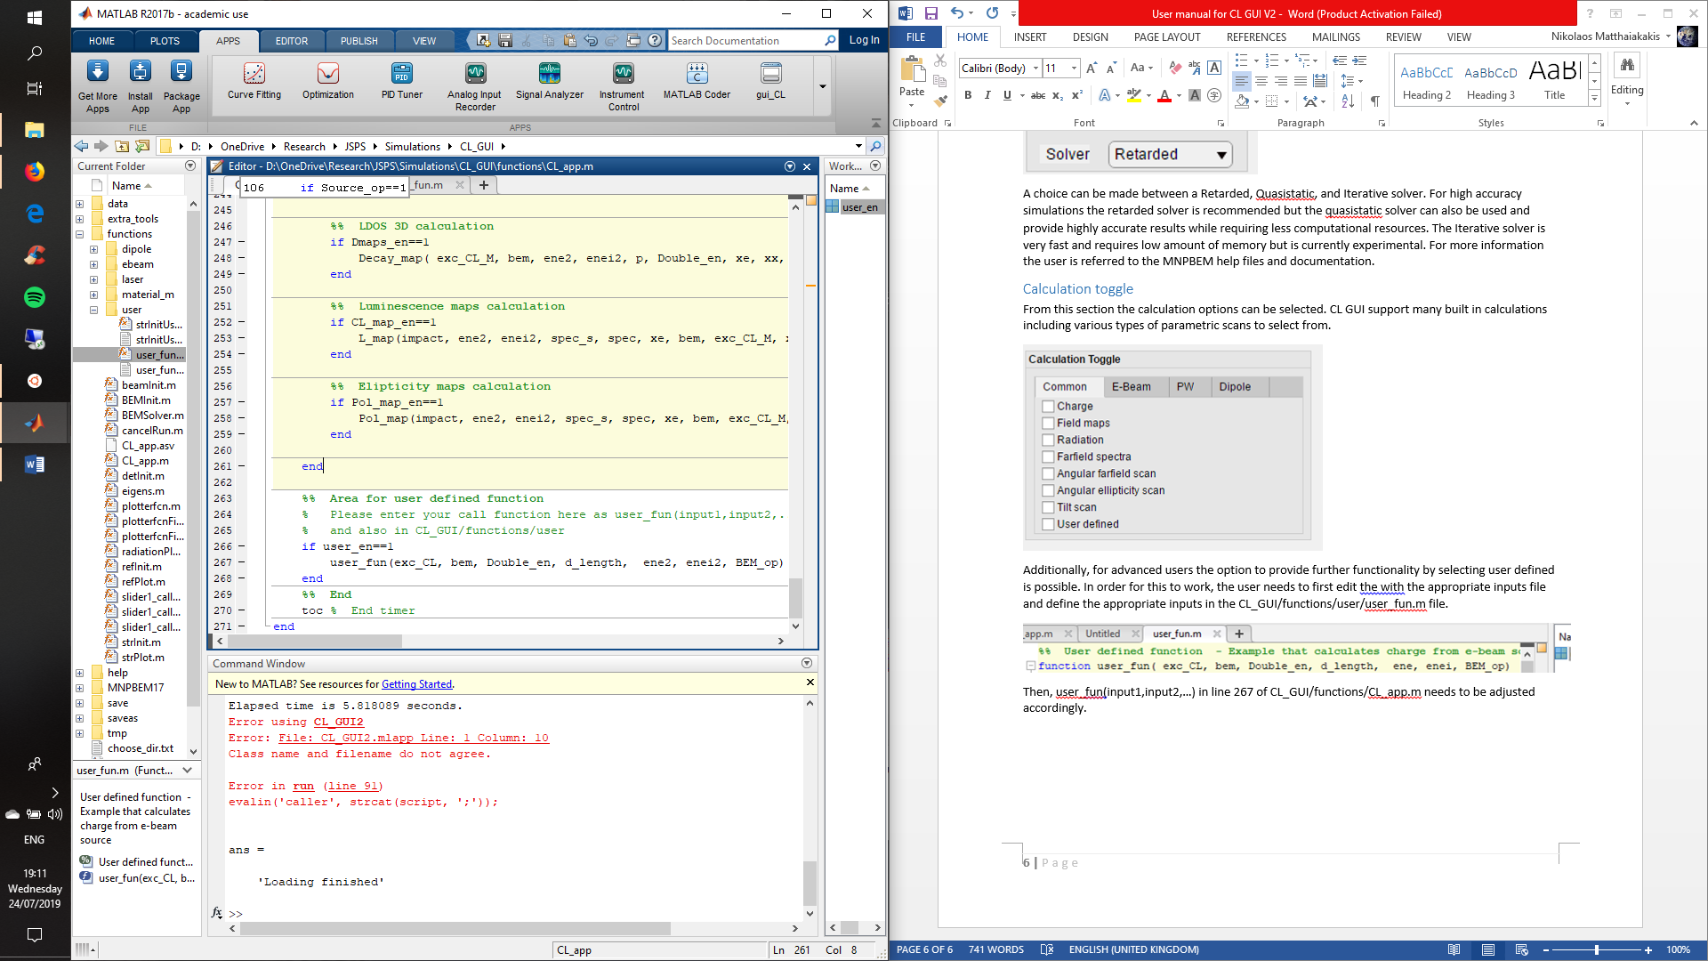

In order to use the GUI generated values as inputs in the user_fun() knowledge of the variable names generated is required. In order to obtain this information the advanced user can right click/edit on the MNPBEM_GUI.mlapp file. This opens the app designer tool of Matlab that allows the user to edit or view the code behind the GUI. By selecting an input value window in the design view and visualizing its callback function in the code view, the exported variable name can be seen.

## Structure

The simulation structure can be defined from the **Structures options** section. A structure preview is available.

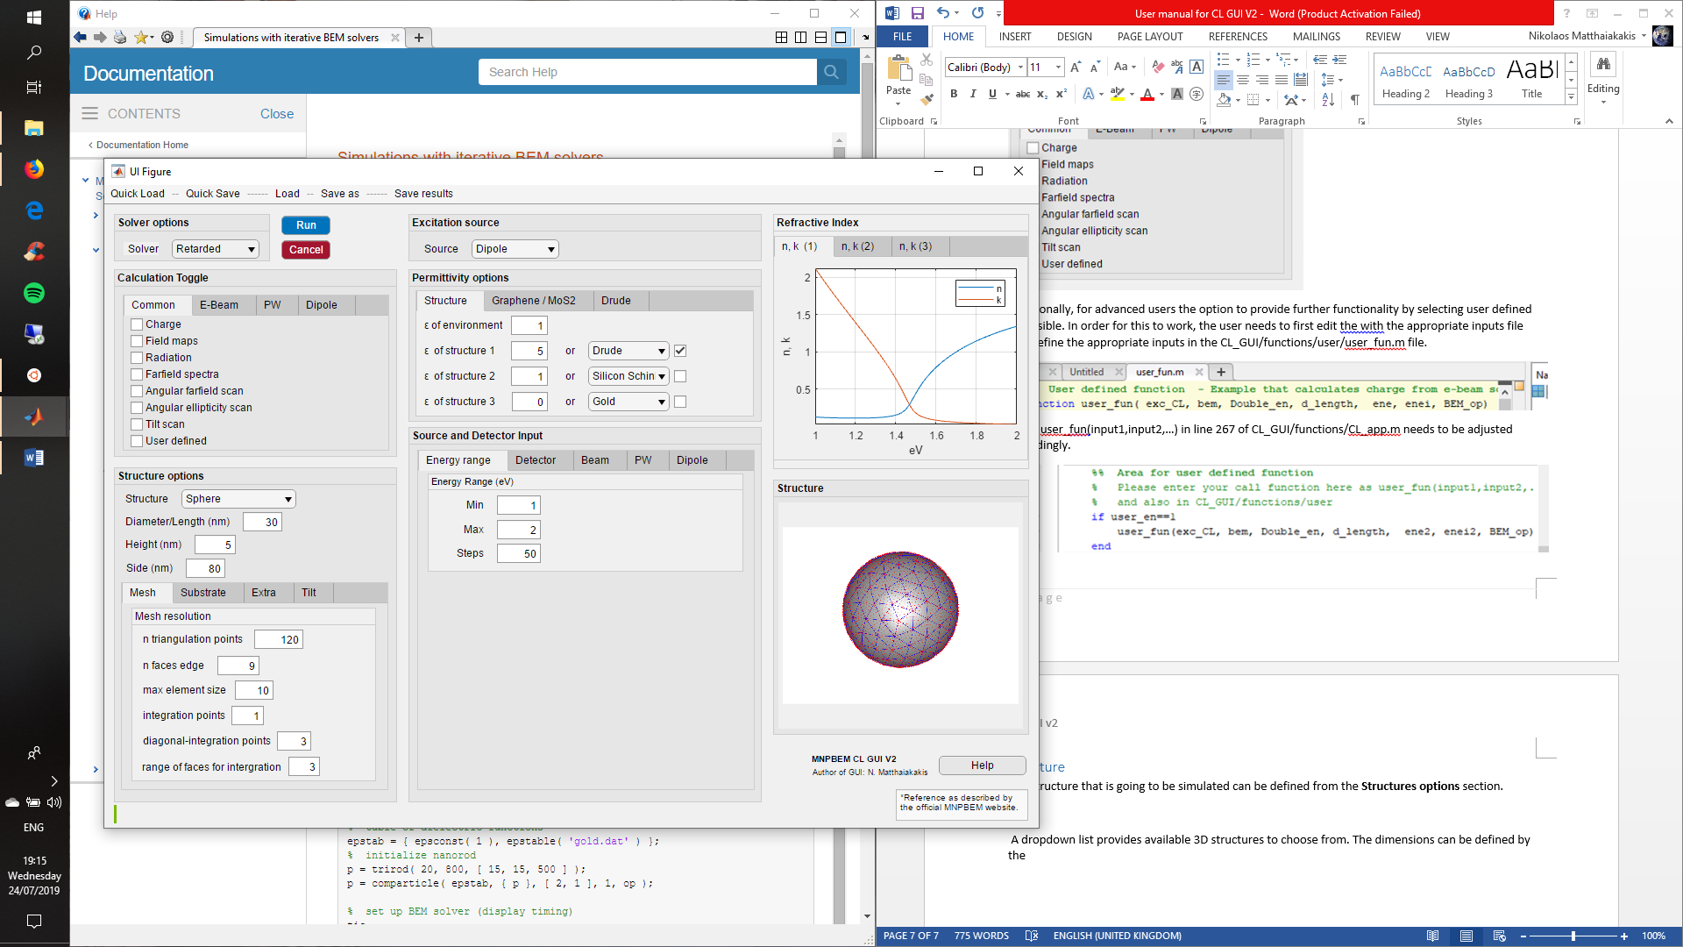

**Structure list:** A dropdown list provides available 3D **structures** to choose from. User defined structures are also supported for advanced users and will be discussed later.



**Dimensions:** The dimensions can be defined by the following input windows.



**Substrates:** Substrates are supported and can be enabled and defined from the substrate tab. Up to two layer substrates can be enabled by ticking the substrate and substrate 2 options. The substrate length is defined as “Substrate length (nm)” for both x and y direction.

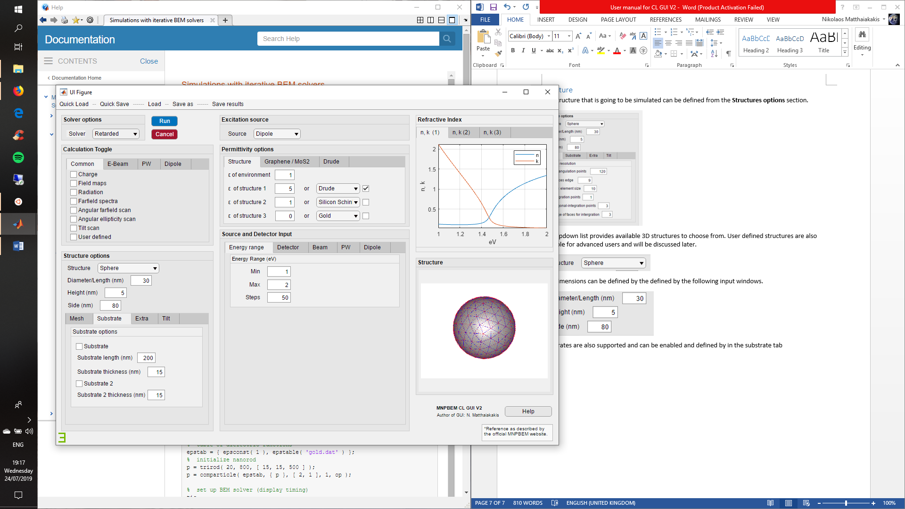

**Extra:** Extra options for the structures can be found at the Extra tab.

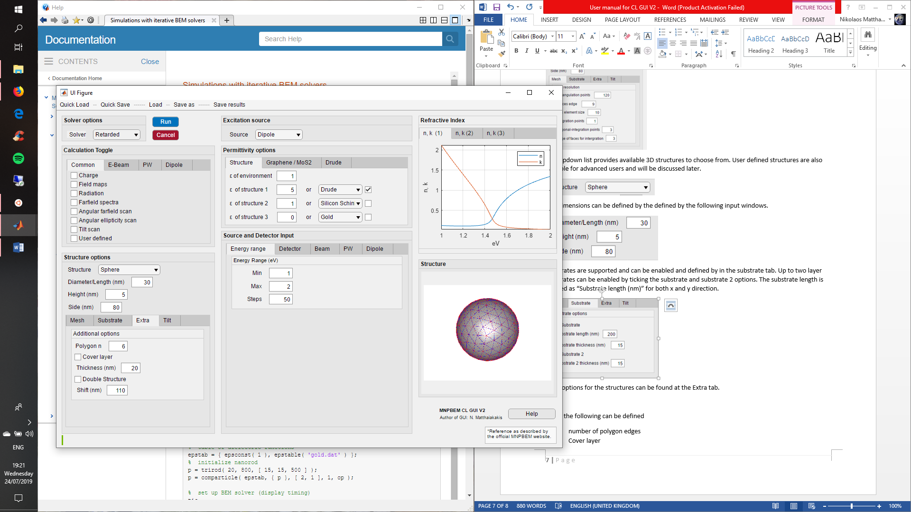

There the following can be defined

* number of polygon edges
* Cover layer
* Enabling a second identical structure and its displacement from the first one for dual structure simulations

**Rotation:** The structure can also be rotated around the x,y,z by inputting tilt values from the tilt tab.

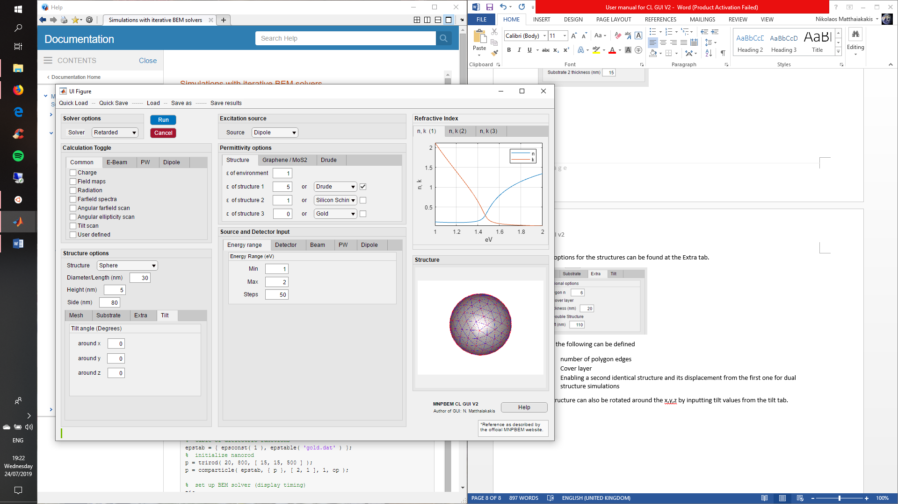

**Mesh:** Definition of the discretization options for the structure are available from the Mesh tab. Care is required when choosing these values in order to achieve accurate results. Nevertheless, the default values should be suitable for most simulations.



For more information please visit the Particle/Particle integration information in the MNPBEM help.

**User defined structure:** For users with some experience in the MNPBEM code, it is possible to import your own user defined structure (possibly even from a CAD software). This can be done by selecting “user defined” in the structure dropdown list and editing MNPBEM_GUI/Functions/user/strInitUser.m similarly to the example that can be found there. By using the variables listed in the following table as inputs for the user defined structure function, the structure parameters can be controlled from the GUI.

|  |  |
| --- | --- |
| Function variables for strInitUser and corresponding input in GUI | |
| **Variable** | **GUI input** |
| typeStr | Structure (Choice between different structure types) |
| Double_en | Extra/double structure (Enables double structure) |
| d_length | Diameter/Length (Defines length of structure) |
| edge_profile | Height (Defines height of structure) |
| Cover_en | Extra/Cover layer (Enables cover layer) |
| epstab | Permittivity options (Provides the refractive index values) |
| op | Solver (Provides BEM settings) |
| ax_el | Dimensions for ellipsoid |
| d_c | Extra/Thickness (Defines cover layer thickness) |
| shift_l | Extra/Shift (Shift between two structures) |
| d_length2 | Extra/width (Defines length of second dimension) |
| d_length3 | Substrate length (Defines substrate x, y length) |
| angles_n | Extra/Polygon n (Defines polygon angle number) |
| grid_1 | Mesh/n triangulation points |
| grid_2 | Mesh/n faces edge |
| hdata | Mesh/Max element size |
| substrate | Substrate (Enables substrate) |
| sub_t | Substrate thickness (Defines substrate thickness) |
| substrate2 | Substrate 2 (Enables second substrate layer) |
| sub_t2 | Substrate 2 thickness (Defines second substrate thickness) |
| xtilt | Tilt/Around x (Defines tilt around x axis) |
| ytilt | Tilt/Around y (Defines tilt around y axis) |
| ztilt | Tilt/Around z (Defines tilt around z axis) |
| dip_p | Source and detector input/Dipole/Dipole position (Defines quantum dot position) |
| Source_op | Source (Choice of source) |
| qd_en | Source and detector input/Dipole/Replace dipole with QD (Defines quantum dot position) |

## Excitation source

The exaction source can be easily selected from the **Excitation source** section dropdown list. The available options are Plane wave, Dipole, and E-Beam.

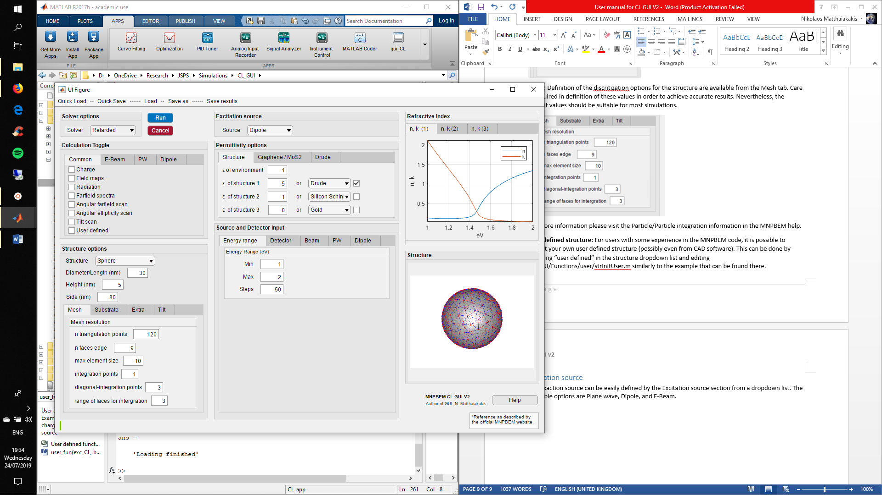

## Permittivity options

The permittivity for each structure can be defined from the **permittivity options** section. The refractive index of each structure can then be seen at the **Refractive index** section.

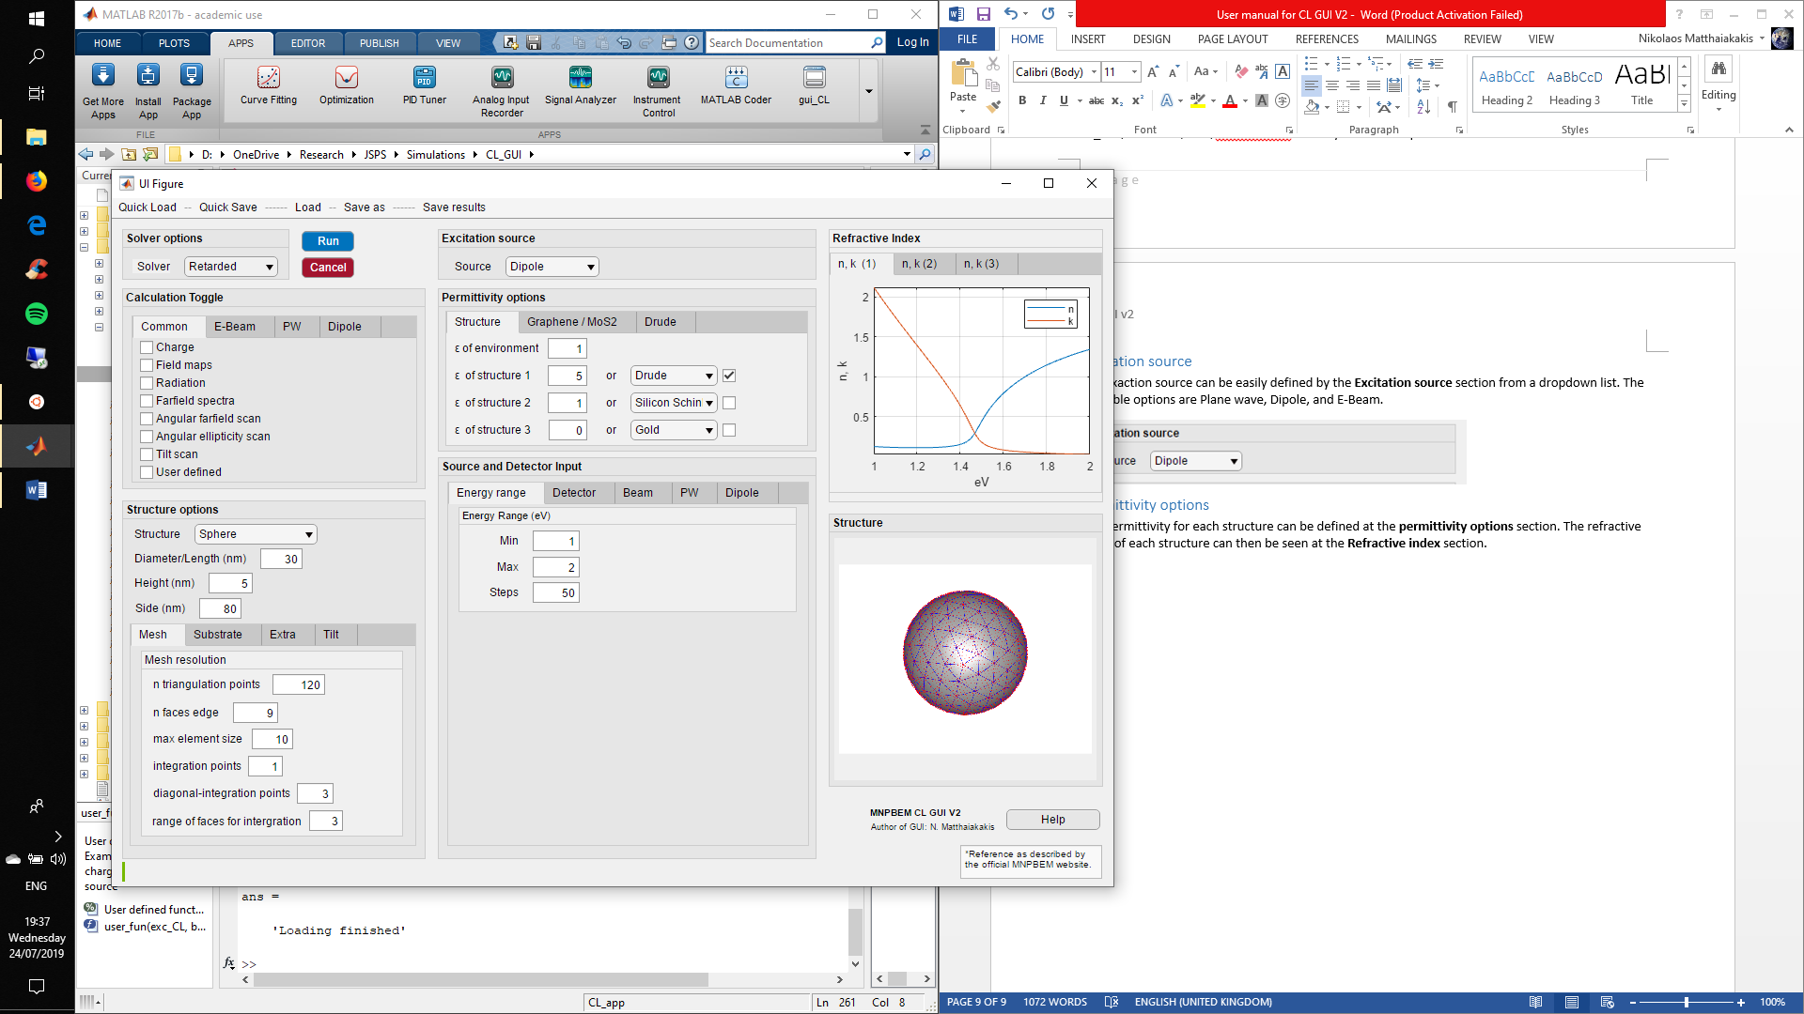

Structure 1 corresponds to the main structure of the simulation.

Structure 2 corresponds to either of the following

* Second structure for dual structure simulations
* Substrate
* Cover layer

Structure 3 corresponds to the second layer of the substrate.

Permittivity can be defined either non-dispersive as a stable value or through tabulated data. Material models for graphene [9] ( [10] for lossless) and MoS2  [11] as well as a Drude model are supported. The material and Drude models work by instantly exporting tabulated data which can then be selected from the dropdown list for each structure.

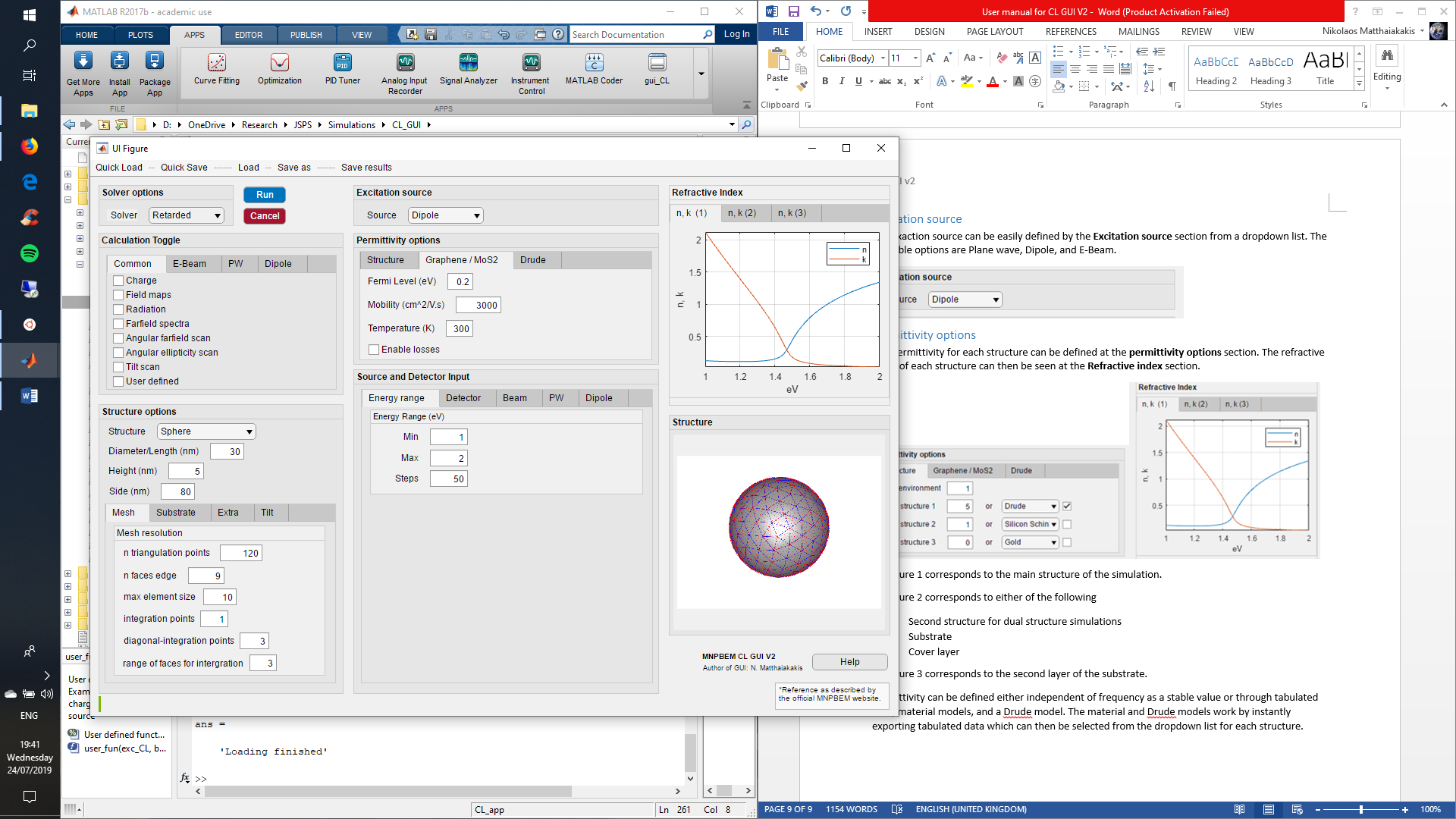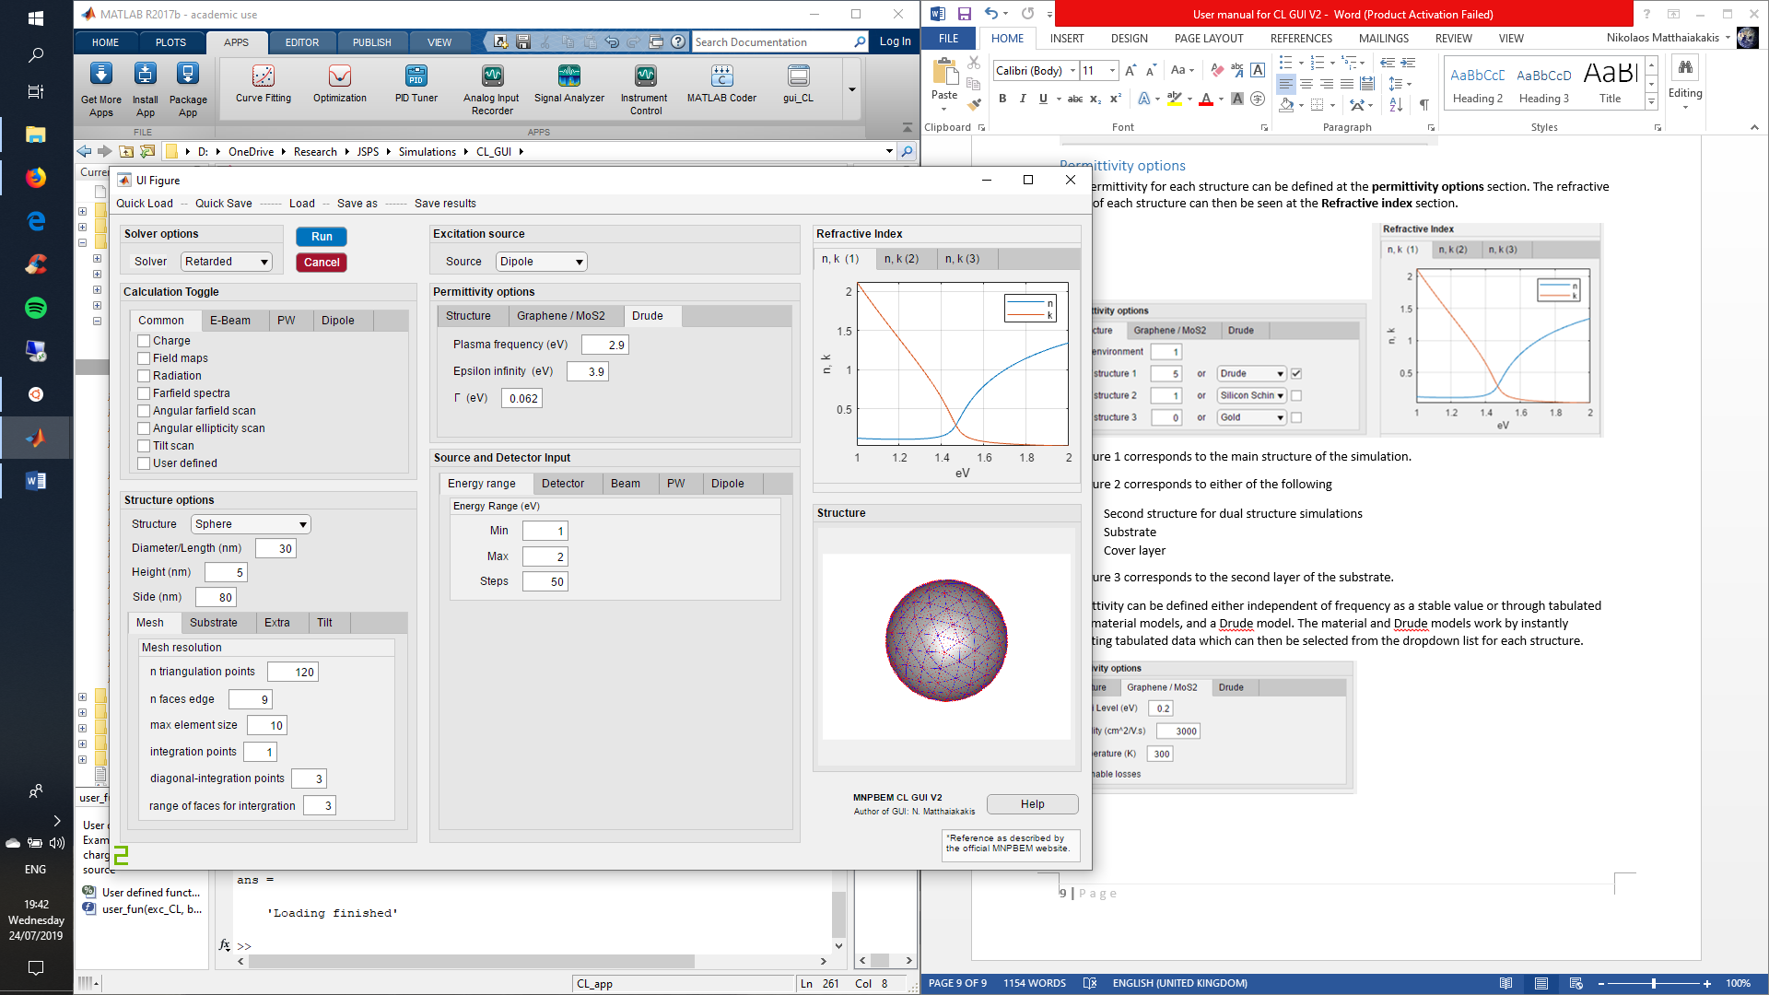

**User defined permittivity:** For user defined material properties a tabulated file of the refractive index needs to be placed at MNPBEM_GUI/MNPBEM17/Material/@epstable named user1/user2/ or user3. The data needs to be in in columns as [“Energy in eV” n k].

## Energy range, Detector options, Source options

The Source and Detector input section can be used to define the simulation energy range, the detector settings, as well as the source settings.

**Energy range for simulation:** Selecting the simulation energy range is very simple and can be done in the energy range tab.

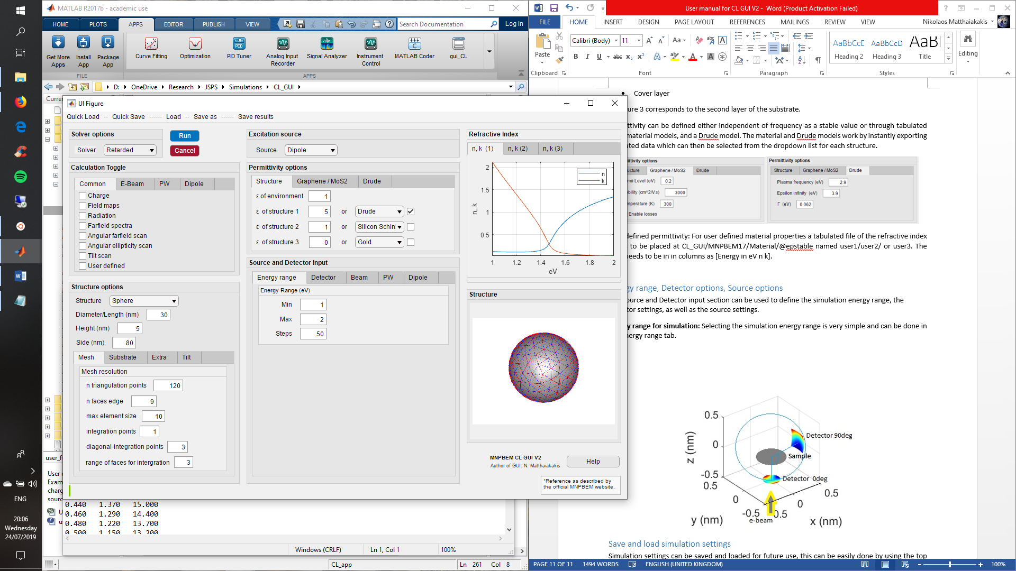

**Detector options:** The detector options are available at the detector tab. Detector position (detector angle), detector size (Detector range), detector distance from sample (Radius), detector mesh (mesh), spatial range (Field detector spatial range, used for field maps), and colourmap values for field maps can be defined in this tab. (rotation on the XZ plane is reverted in relation to the MNPBEM toolbox)

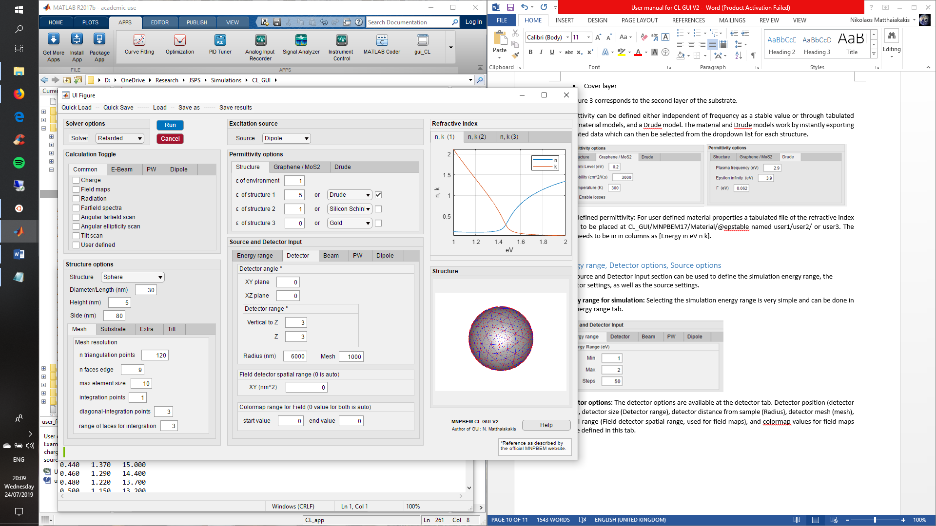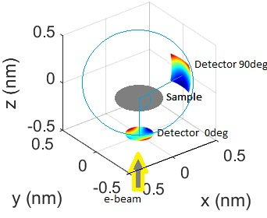

**Electron beam settings:** The electron beam source settings including kinetic energy, beam width, position and resolution for mapping. It is advised to keep the beam width smaller than the mesh size.

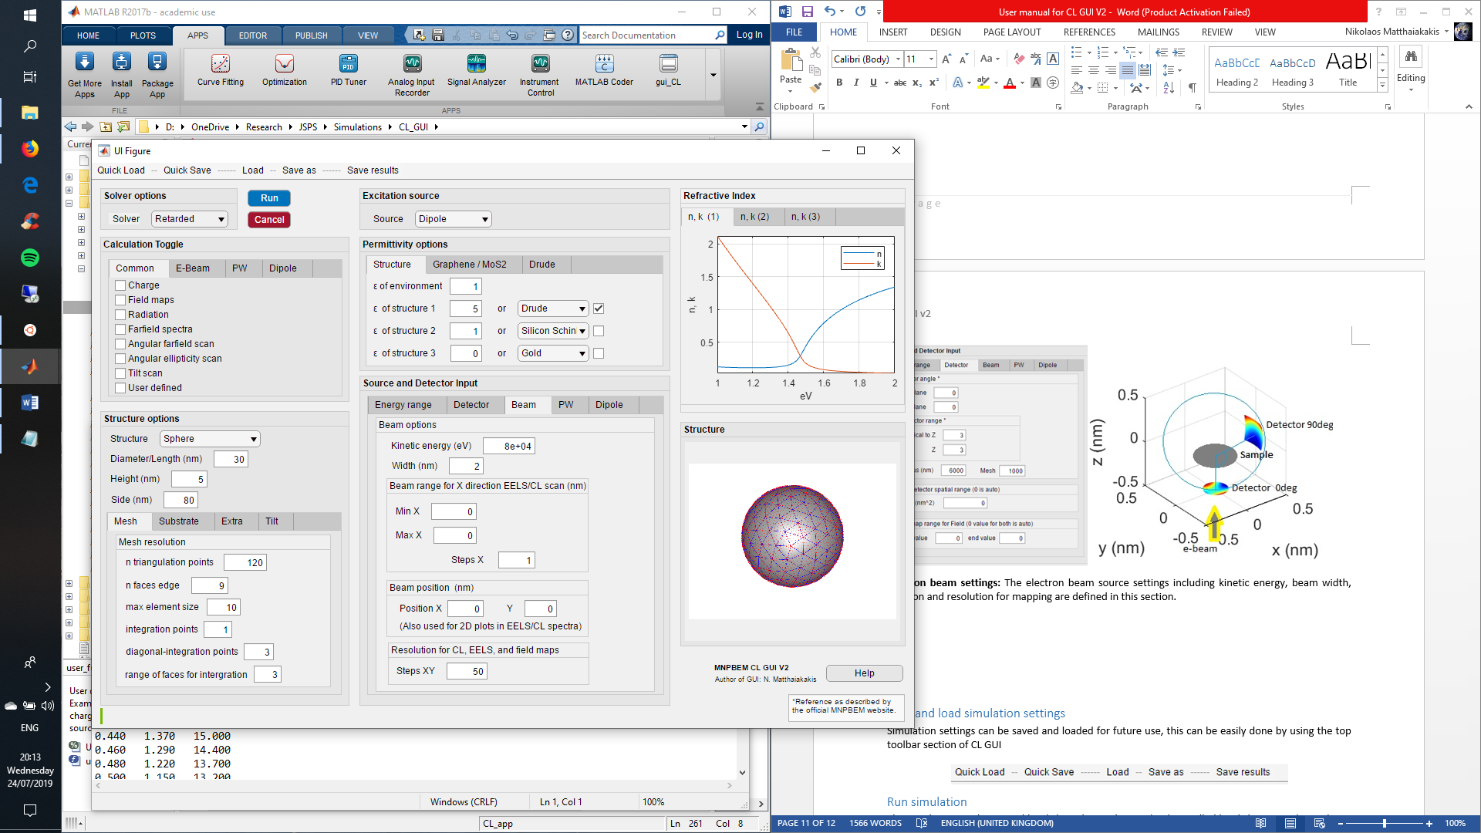

**Plane wave settings:** Polarization of light can be selected (s and p)

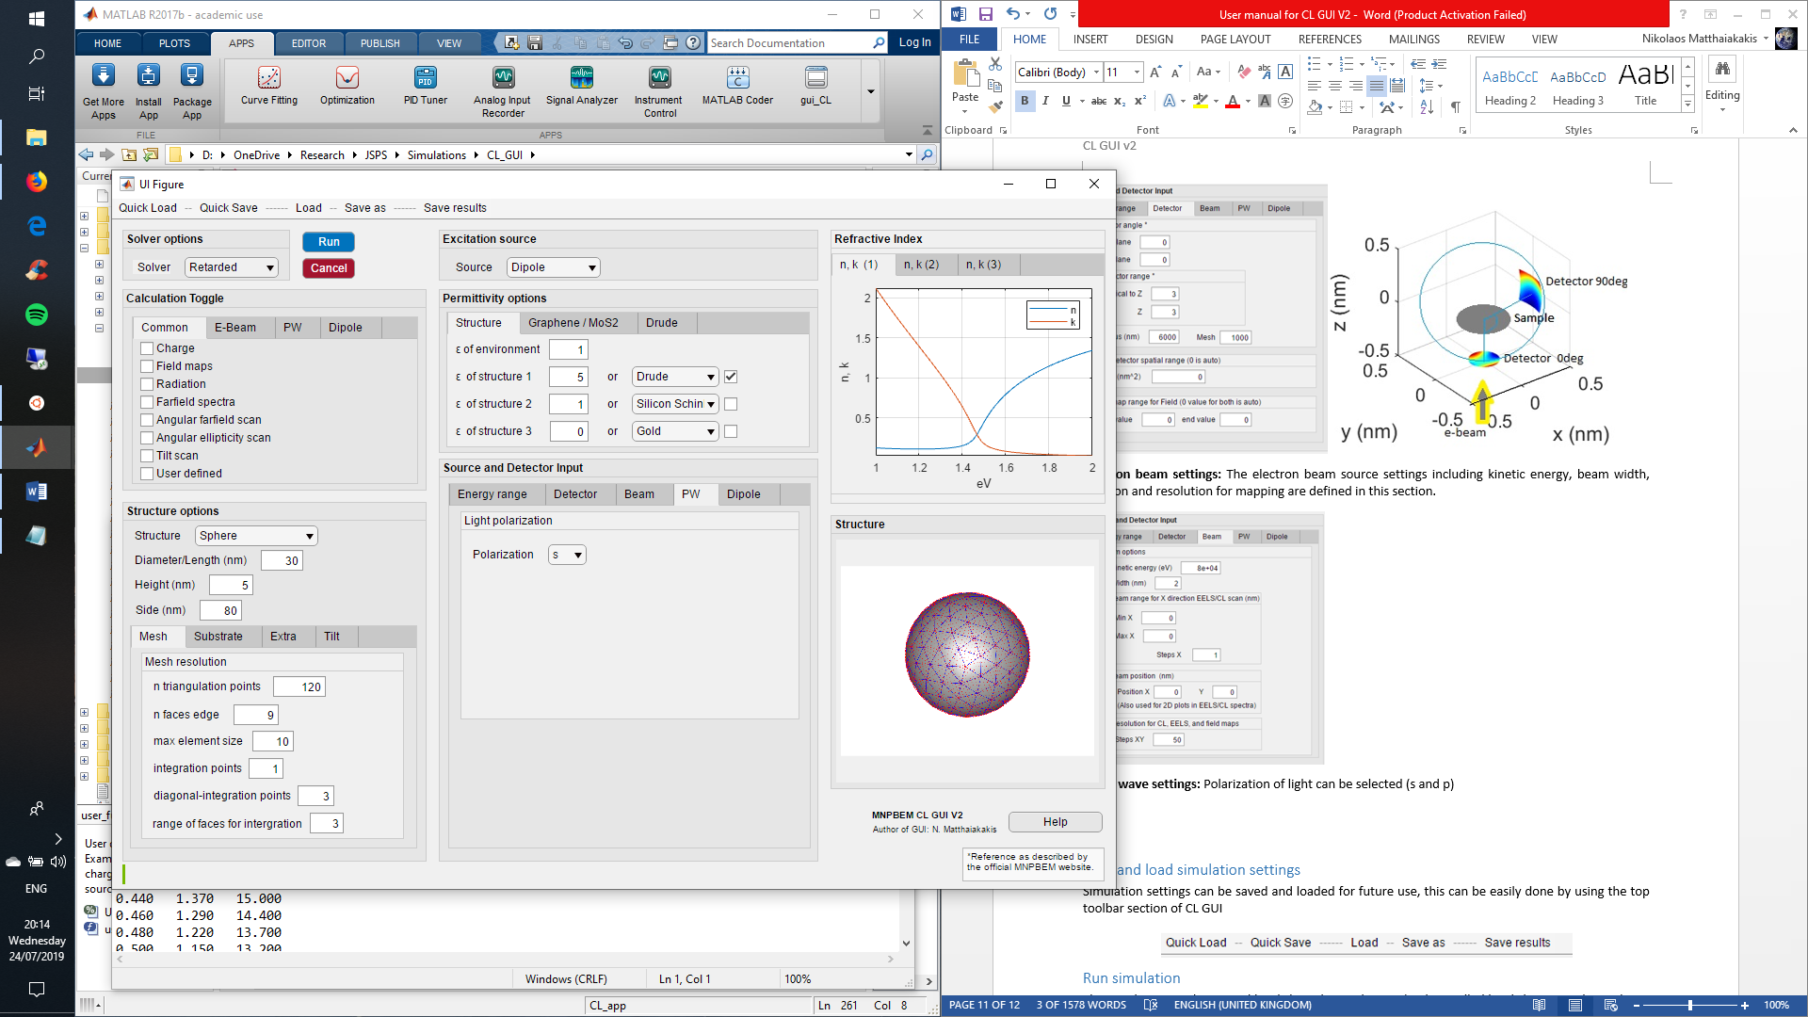

**Dipole settings:** The dipole position and oscillation direction can be defined

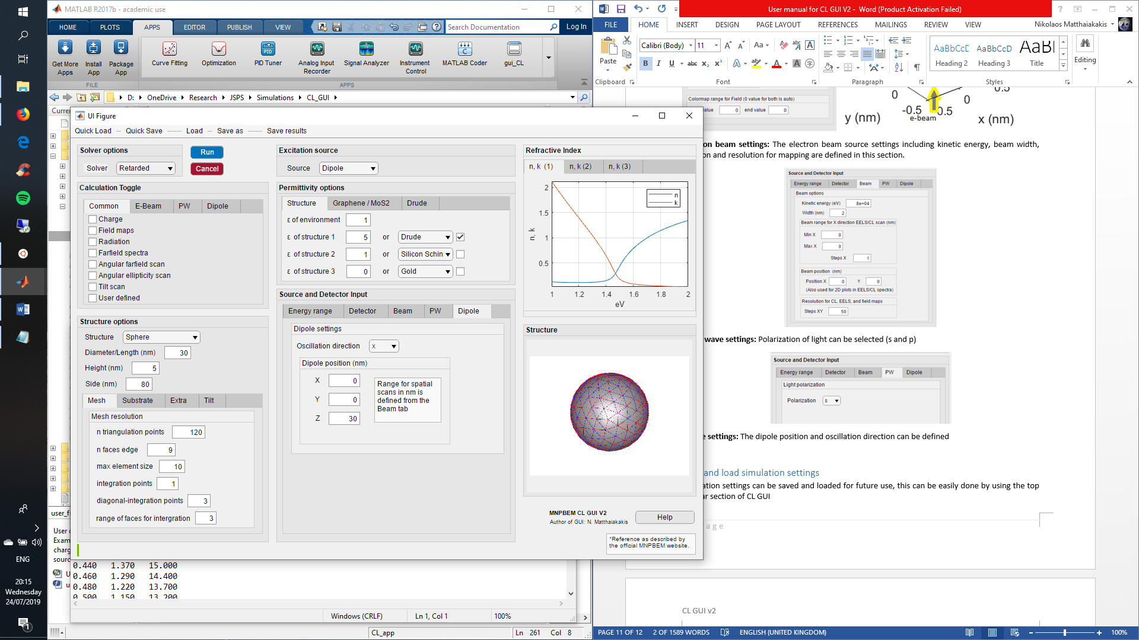

## Save and load simulation settings

Simulation settings can be saved and loaded for future use, this can be easily done by using the top toolbar section of MNPBEM-GUI.

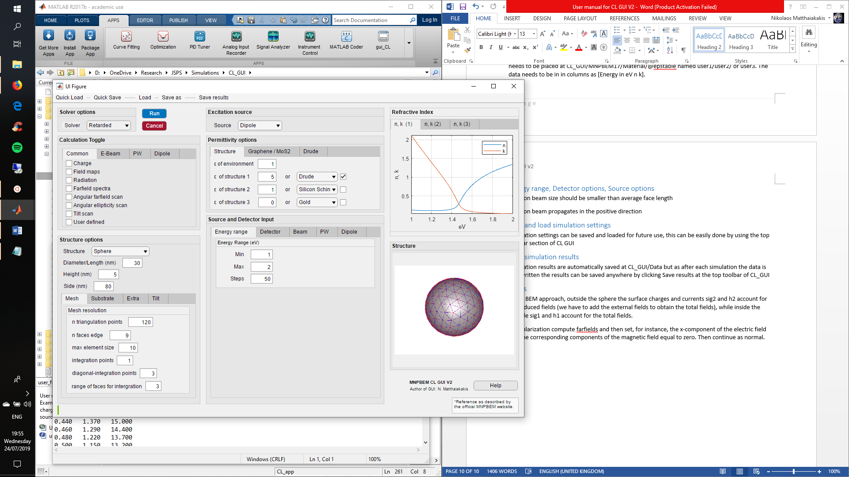

## Run simulation

The simulation can be started by clicking the run button (and cancelled by clicking cancel or ctrl+c in the Matlab terminal).

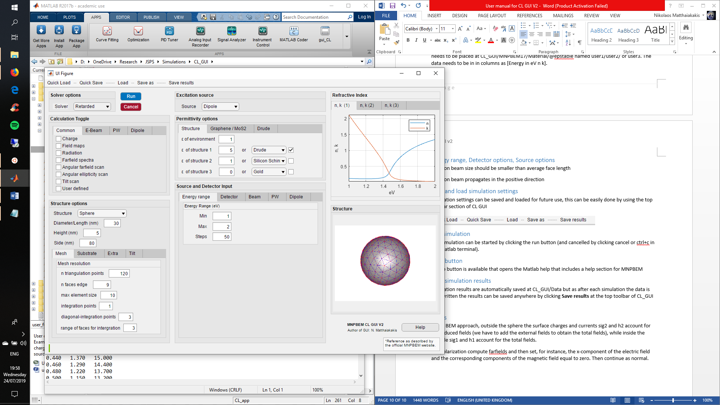

## Save simulation results

Simulation results are automatically saved at MNPBEM_GUI/Data but since for each simulation the data is overwritten the results can be saved anywhere by clicking **Save results** from the top toolbar of MNPBEM_GUI

## Help button

A help button is available that opens the Matlab help that includes a help section for MNPBEM

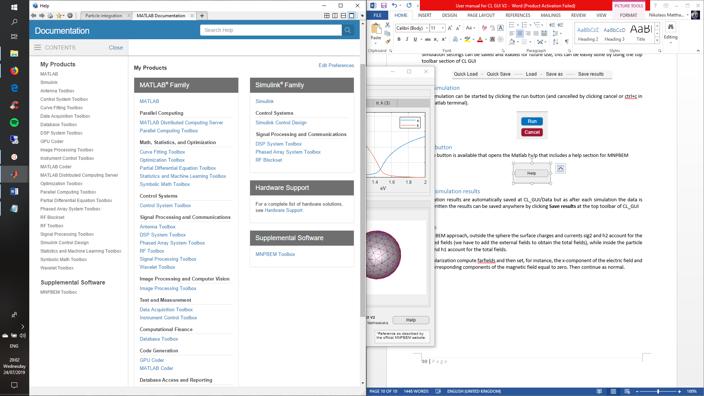

# References

1. U. Hohenester and A. Trügler, "MNPBEM - A Matlab toolbox for the simulation of plasmonic nanoparticles," Comput. Phys. Commun. **183**, 370–381 (2012).

2. J. Waxenegger, A. Trügler, and U. Hohenester, "Plasmonics simulations with the MNPBEM toolbox: Consideration of substrates and layer structures," Comput. Phys. Commun. **193**, 138–150 (2015).

3. U. Hohenester, "Making simulations with the MNPBEM toolbox big: Hierarchical matrices and iterative solvers," Comput. Phys. Commun. **222**, 209–228 (2018).

4. U. Hohenester, "Simulating electron energy loss spectroscopy with the MNPBEM toolbox," Comput. Phys. Commun. **185**, 1177–1187 (2014).

5. V. Myroshnychenko, J. Rodríguez-Fernández, I. Pastoriza-Santos, A. M. Funston, C. Novo, P. Mulvaney, L. M. Liz-Marzán, and F. J. García De Abajo, "Modelling the optical response of gold nanoparticles," Chem. Soc. Rev. **37**, 1792–1805 (2008).

6. F. J. Garc??a De Abajo, "Optical excitations in electron microscopy," Rev. Mod. Phys. **82**, 209–275 (2010).

7. F. García de Abajo and J. Aizpurua, "Numerical simulation of electron energy loss near inhomogeneous dielectrics," Phys. Rev. B - Condens. Matter Mater. Phys. **56**, 15873–15884 (1997).

8. F. J. García de Abajo and A. Howie, "Retarded field calculation of electron energy loss in inhomogeneous dielectrics," Phys. Rev. B - Condens. Matter Mater. Phys. **65**, 1154181–11541817 (2002).

9. G. W. Hanson, "Dyadic Green’s Functions and Guided Surface Waves for a Surface Conductivity Model of Graphene," J. Appl. Phys. **103**, 064302; DOI:10.1063/1.2891452 (2007).

10. T. Stauber, N. M. R. Peres, and a. K. Geim, "Optical conductivity of graphene in the visible region of the spectrum," Phys. Rev. B - Condens. Matter Mater. Phys. **78**, 1–8 (2008).

11. B. Mukherjee, F. Tseng, D. Gunlycke, K. K. Amara, G. Eda, and E. Simsek, "Complex electrical permittivity of the monolayer molybdenum disulfide (MoS_2) in near UV and visible," Opt. Mater. Express **5**, 447 (2015).